GRASSING BARE PATCHES DEMONSTRATION

FARM 3 - Allan

May 2021

What has happened so far

40 Weeks Later

Some rain falls but the autumn rainfall has been below average. Fortunately the predicted rain in early May eventuated a days after sowing the grass seed. You can sometimes get the timing right. There are signs of grass germination in both the Common Improved and Variation 1 plots which I assume are one or more of the native C3 grasses. I believe that the cocksfoot would not have germinated yet.

With plenty of feed around the farm, the temporary fence seems to continue restricting native grazing and I have still not seen any Kangaroos or Wallabies etc on the demonstration plots. Both Control A and Control B are good examples of the benefits of controlling the grazing pressures on an area / paddock from either livestock or native animals.

I have included pictures below to show the original site and the current status of the demonstration plots after 40 weeks as well as the plots after mulching and sowing.

As previously observed there is an abundance of kangaroo and wallaby grass around the plots inside the basic exclusion fence. Minimal Kangaroo grass is prevalent in any of demonstration plots except the control reinforcing that Kangaroo grass does not like to be disturbed and was easily out competed by the green manure crop.

GRASS SEED & SOWING

I chose to use a combination of both exotic and native grass seed. I have used a native grass mix which suit native wildlife combined with Cocksfoot Lazuly.

NSW DPI website classifies grasses as either C3 or C4 plants. C3 plants are adapted to cool season establishment and growth in either wet or dry environments. On the other hand, C4 plants are more adapted to warm or hot seasonal conditions under moist or dry environments. A feature of C3 grasses is their greater tolerance of frost compared to C4 grasses. C3 species also tend to generate less bulk than C4 species; however, feed quality is often higher than C4 grasses. Cocksfoot is a C3 grass.

The native grass seed mix contains
C3 GRASSES
- Native Wheat grass (Anthosachne scabra)
- Evans Wallaby grass (Rytidosperma caespitosa)
- Oxley Wallaby grass (Rytidosperma bigeniculata)
- Burra Weeping grass (Microlaena Stipoides var. Burra)
- Griffin Weeping grass (Microlaena Stipoides var. Griffin)
- Common Tussock grass (Poa labillardieri)

C4 GRASSES
- Purple Wire Grass (Aristida personata)
- Kneed spear grass (Austrostipa bigeniculata)
- Scent Top grass (Capillipedium spicigerum)
- Silky top Lemon Scented grass (Cymbopogon obtectus)
- Silky Bluegrass (Dichanthium sericeum)
- Curly Mitchell grass (Astrebla lappacea)

I used a sowing rate for the native grass seed mix and cocksfoot of 12 Kg/Ha, which equates to about 30 grams per 5m X 5m plot.

All vegetation was slashed / mulched prior to sowing. To ensure contact with the soil, a light coating of compost was applied after sowing the seed to help ensure the seed / soil contact.

The original control plot was 5m X 10m. Half of the control was mulched, and seeded (Control Plot A) and the other half left totally undisturbed (Control Plot B).

BACK GROUND INFORMATION

COMMON IMPROVED PLOT
The Common Improved plot had lime added to the surface and was to be incorporated to a depth of 5cm by hand. My compact soil did not allow for the lime to be incorporated to that depth and was “scratched” into a maximum depth of 2cm. The green manure crop consisting of 90% ryecorn and 10% crimson clover was broadcast across the plot at a rate of 40 grams per m². The Common Improved plot was then covered with jute mesh. The jute mesh as covered with compost obtained from the Queanbeyan Palerang Regional Council waste minimisation centre.

VARIATION 1 PLOT
The Variation 1 plot had lime distributed in the same manner as the Common Improved plot. For this plot mechanical means were used to incorporate the lime. The four tines on a box grader were used to break up the soil to a depth of approximately 10cm. The green manure crop was then broadcast at the same rate of 40 grams per m². The plot was then covered with the compost obtained from the Queanbeyan Palerang Regional Council waste minimisation centre.

VARIATION 2 PLOT
The variation plot 2 was completed a little later (5 days) after the common improved and Variation 1 plots. This variation 2 was without any physical incorporation of the treatments to the plot. The lime was distributed by the same manner as the Common Improved plot and left on the surface and not incorporated. The green manure crop was then broadcast at the same rate of 40 grams per m². The plot was then lightly covered with meadow hay. Pelletised poultry manure (Dynamic lifter) was broadcast on this plot at the same rate as the green manure crop of 40 grams per m². The variation plot 2 was then also covered with the compost obtained from the Queanbeyan Palerang Regional Council waste minimisation centre.

Table of Figures

Figure 1 Common Control Plot – No Treatment September 2020 4
Figure 2 Common Control Plot A May 2021 – Slashed and seeded 4
Figure 3 Common Control Plot B May 2021– No Treatment 4
Figure 4 Common Improved Plot - No treatment September 2020 5
Figure 5 Common Improved Plot May 2021 – Slashed and seeded 5
Figure 6 Common Improved Plot May 2021- Crimson clover present 5
Figure 7 Common Improved Plot May 2021 – Grass germination 6
Figure 8 Variation 1 Plot - No treatment September 2020 7
Figure 9 Variation 1 Plot May 2021- Slashed and seeded 7
Figure 10 Variation 1 Plot May 2021 – Crimson clover 7
Figure 11 Variation 1 Plot May 2021 – Grass germination 8
Figure 12 Variation 2 Plot - No treatment September 2020 9
Figure 13 Variation 2 Plot May 2021- Slashed and seeded 9
Figure 14 Variation 2 Plot May 2021 - crimson clover 9

COMMON CONTROL PLOT

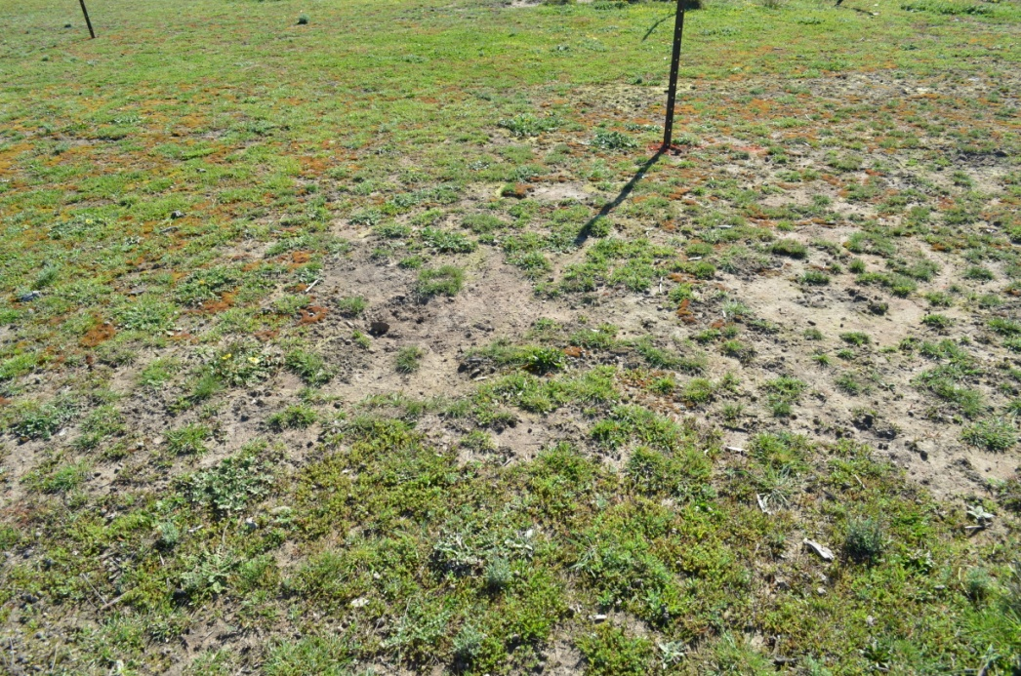
Figure 1 Common Control Plot – No Treatment September 2020

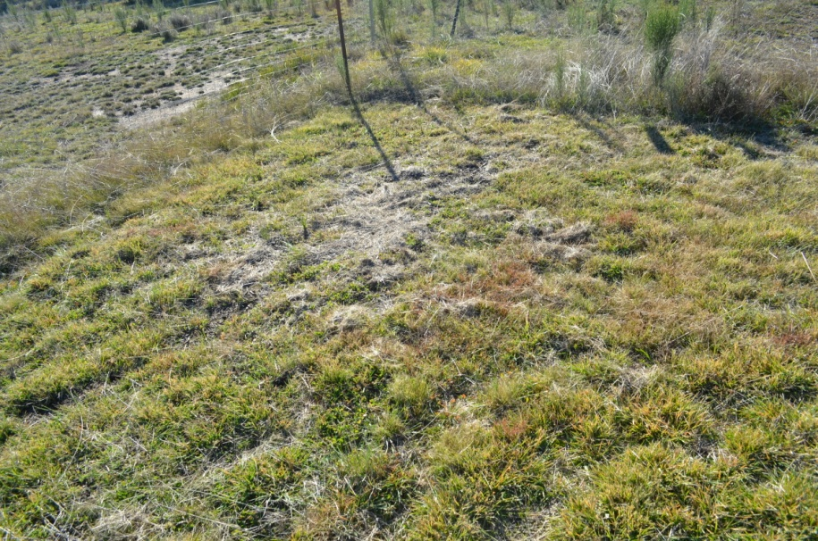
Figure 2 Common Control Plot A May 2021 – Slashed and seeded

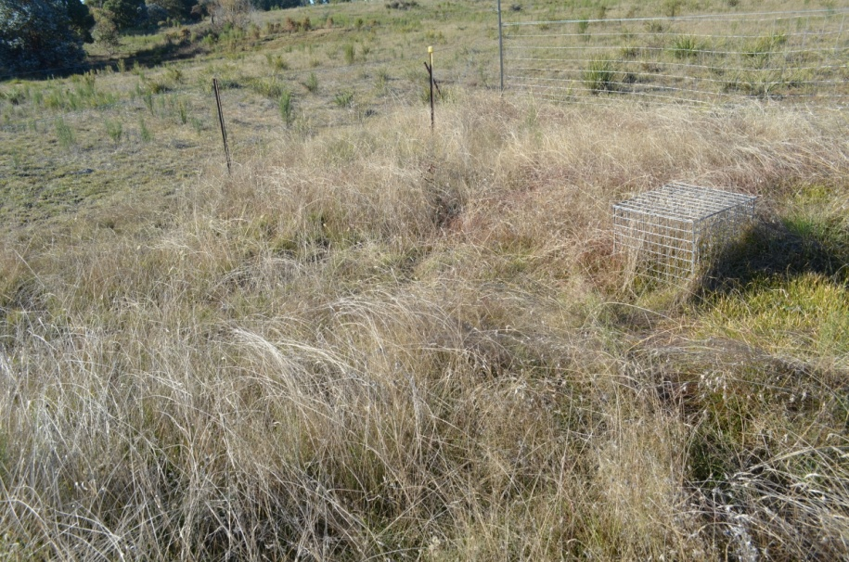
Figure 3 Common Control Plot B May 2021– No Treatment

COMMON IMPROVED PLOT

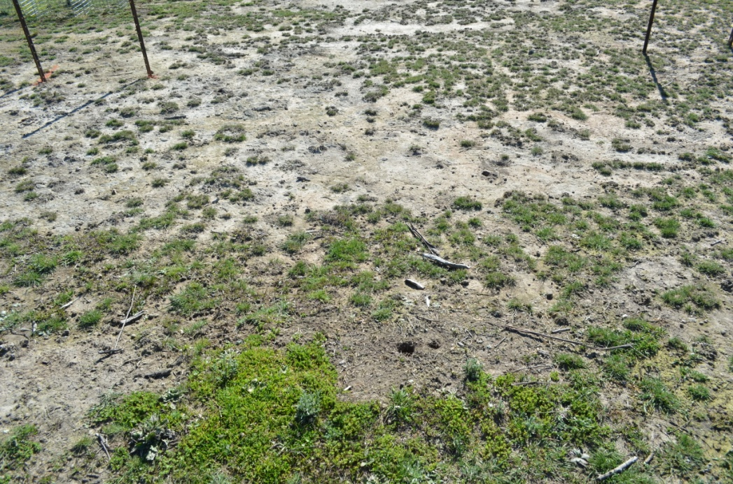
Figure 4 Common Improved Plot - No treatment September 2020

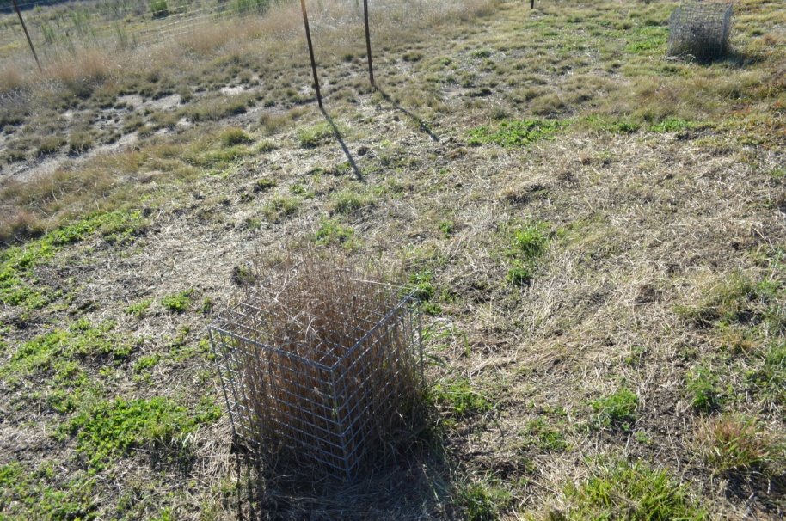
Figure 5 Common Improved Plot May 2021 – Slashed and seeded

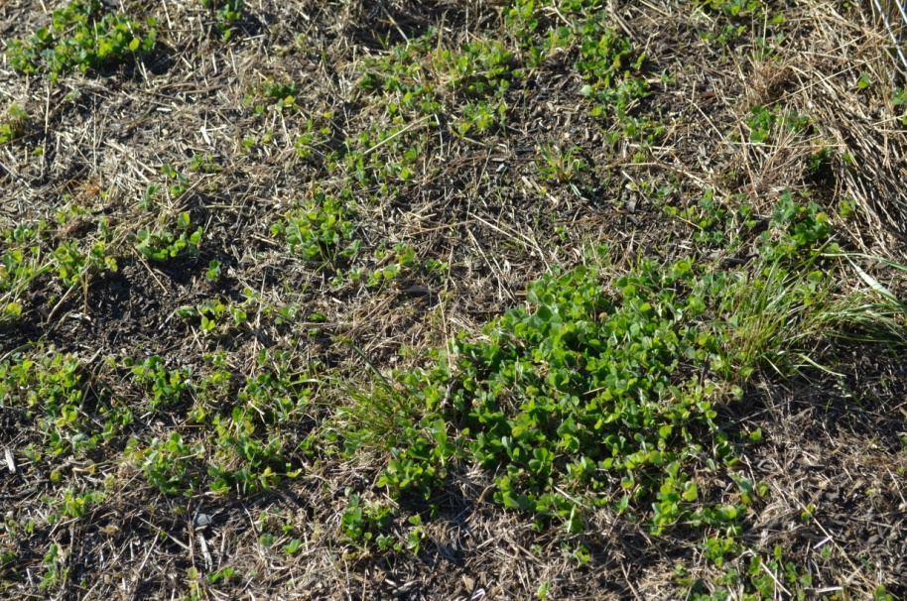
Figure 6 Common Improved Plot May 2021- Crimson clover present

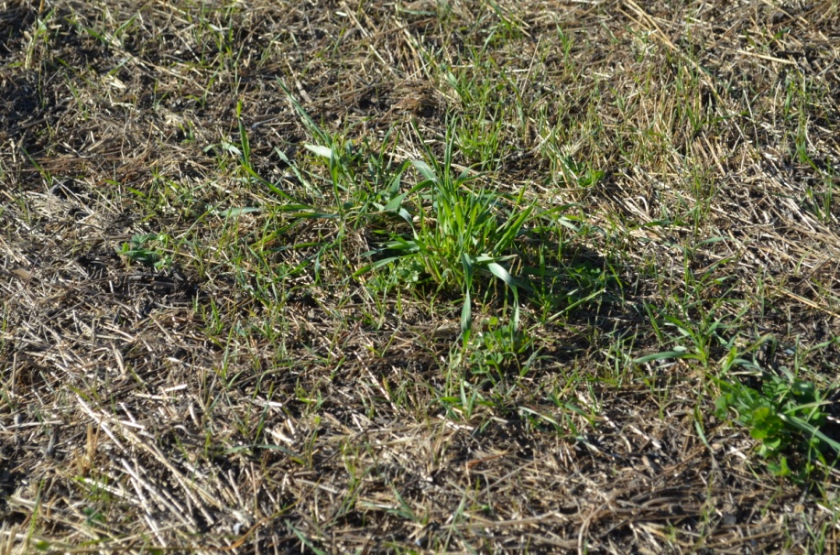
Figure 7 Common Improved Plot May 2021 – Grass germination

VARIATION 1 PLOT

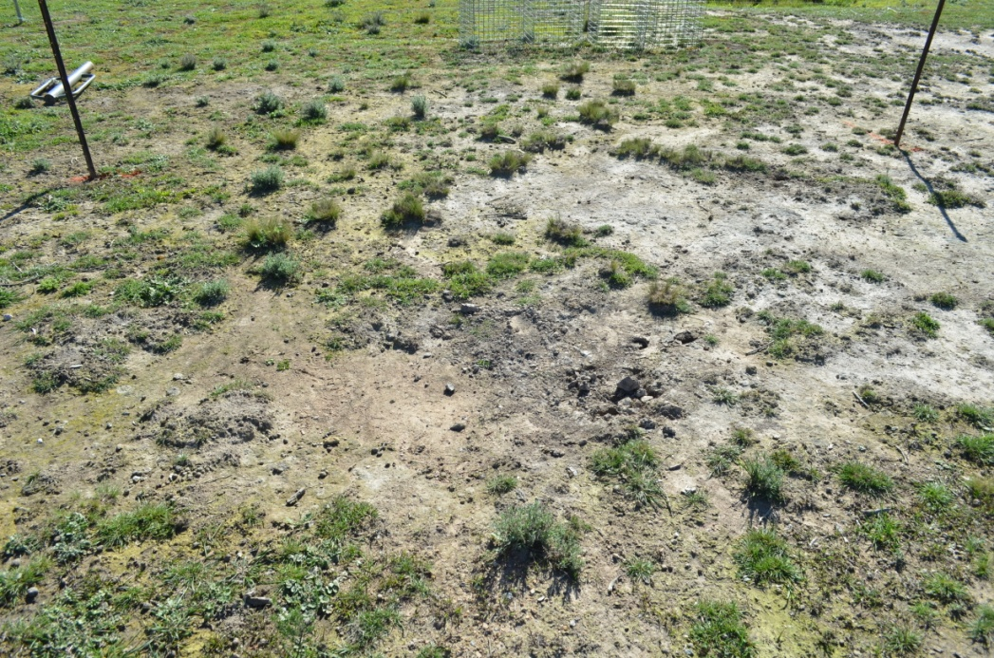
Figure 8 Variation 1 Plot - No treatment September 2020

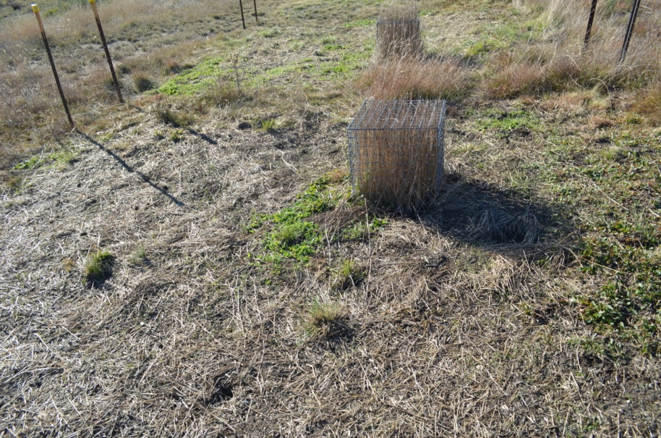
Figure 9 Variation 1 Plot May 2021- Slashed and seeded

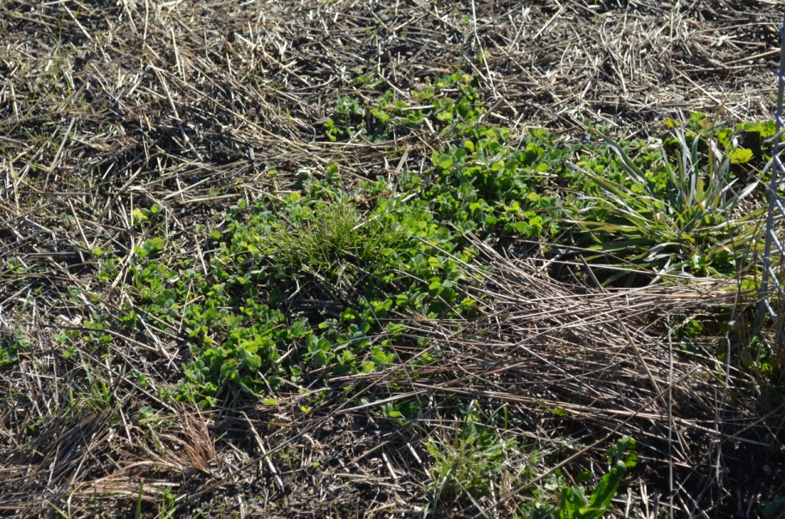
Figure 10 Variation 1 Plot May 2021 – Crimson clover
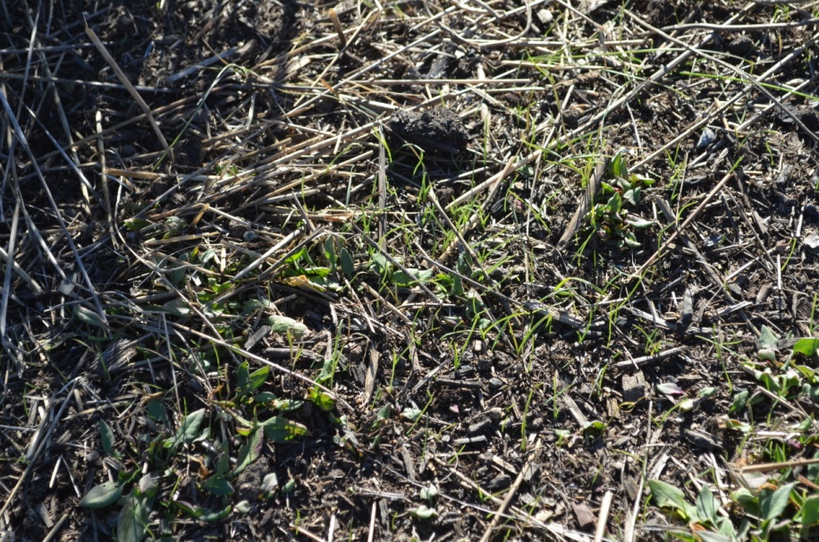
Figure 11 Variation 1 Plot May 2021 – Grass germination

VARIATION 2 PLOT
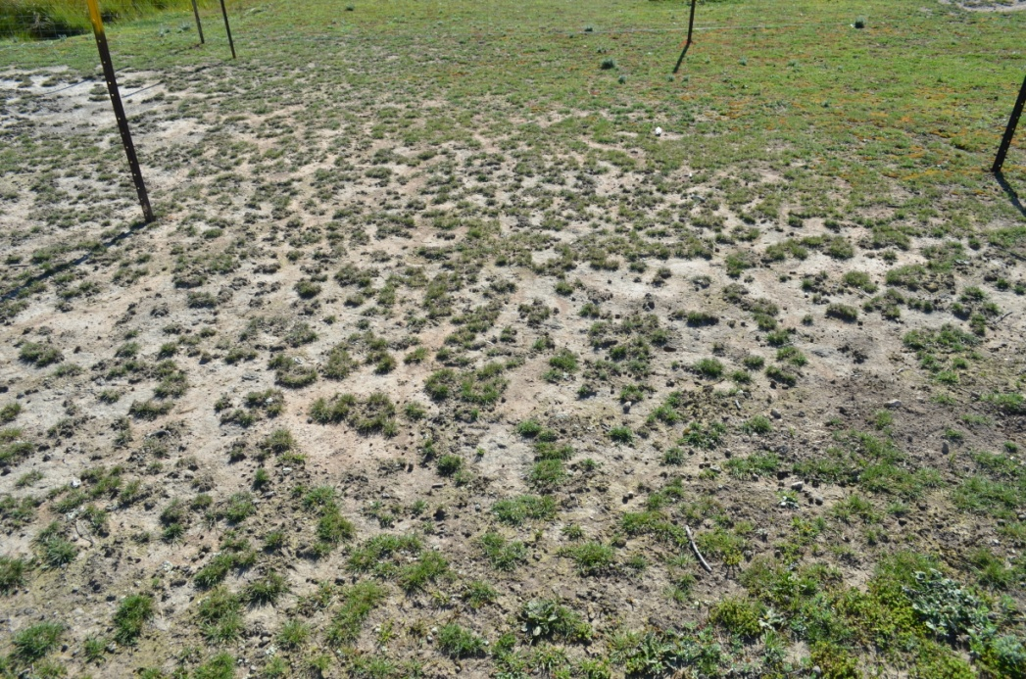
Figure 12 Variation 2 Plot - No treatment September 2020

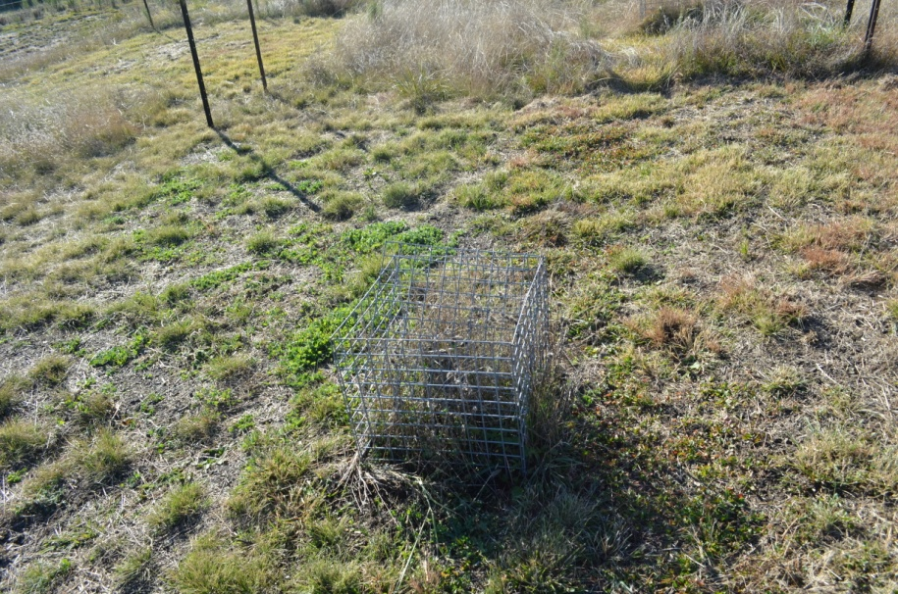
Figure 13 Variation 2 Plot May 2021- Slashed and seeded

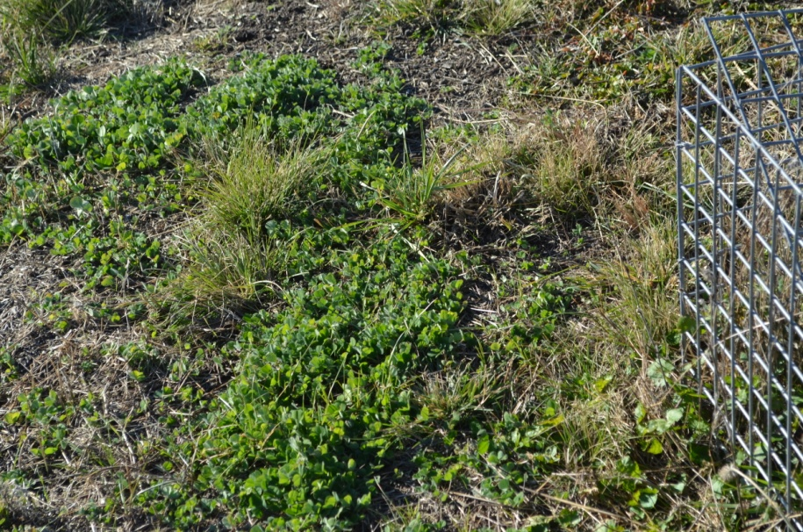
Figure 14 Variation 2 Plot May 2021 - crimson clover

